Practical 9: Graph Traversal: Depth-First Search and
Breadth-First Search
Practical Aim
To implement depth-first and breadth-first traversal on a graph and develop the ability to reason about how the order of exploration changes depending on the traversal strategy used.

Problem 1:
A disaster relief team needs to inspect all buildings in a city after an earthquake. The city is
mapped as a network where buildings are connected by roads. One team starts at a building
and goes as deep into each road as possible before backtracking, while a second team spreads
out level by level — first checking all buildings directly connected to the start, then all buildings
two roads away, and so on. Given the city map as a graph and a starting building, implement
both exploration strategies and print the order in which buildings are visited by each team.
Describe how the order of buildings visited differs between the two strategies on the same
graph. What data structure does each strategy rely on to decide which building to visit next, and
how does that structure cause the difference in order?

For code :

https://github.com/kvvaghasiya49/FDSA/tree/6fb2f463bf1f58ac 408ada5ca8ffdaa64bc82087/DSA

Output:
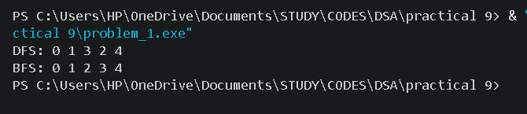

Challenges Faced:
At first, I did not use a visited array, and the program went into an endless loop because the same building was visited again and again through different roads. After adding a visited array and marking a node as visited before moving on, both traversals worked correctly. For DFS, the difficult part was understanding how the recursive calls go deep into one road and then come back to try the next neighbour. condition) before a serve, otherwise the program wrote outside the array or served a token that did not exist.
Learning Outcomes:
I learned how to represent a graph using an adjacency list and how to implement DFS and BFS on it.
I understood that a visited array is necessary to stop the traversal from visiting a node twice or looping forever.
I learned that DFS uses a stack (the recursion call stack) and goes deep first, while BFS uses a queue and goes level by level, and this is why their visiting orders are different.

Key Questions / Analysis / Interpretation to be Evaluated During/After
Implementation:

1. [Problem 1] Both strategies visit every reachable node exactly once. If the goal is simply to check whether a specific building exists in the network, which strategy would find it sooner if the building is very close to the start? What if it is very far and deep? Explain your reasoning without tracing through any specific example.
Ans :
If the building is very close to the start, BFS would find it sooner. BFS checks all buildings one road away, then two roads away, and so on, so a nearby building is reached before the traversal goes far. DFS might go deep into a different road first and visit many unnecessary buildings before coming back to the nearby one.

2. [Problem 1] Your DFS implementation likely uses recursion. What real-world constraint on the computer could cause your recursive DFS to fail on a very large city map, and how would you restructure your solution to avoid that failure?
Ans :
Every recursive call is stored on the call stack, and the call stack has a limited size in memory. On a very large city map with a very long chain of roads, the recursion becomes very deep, the stack memory runs out, and the program crashes with a stack overflow error.

